**ModerMouth Instructions for GUI version 03.03.09**

**Brad Story**

1. At the Matlab prompt “>>” type the following

>>ModerMouthSetParamsTremor

1. The window shown below should now appear. You can press the “RUN” button without doing anything else and you should soon hear a monotone “ih” vowel.

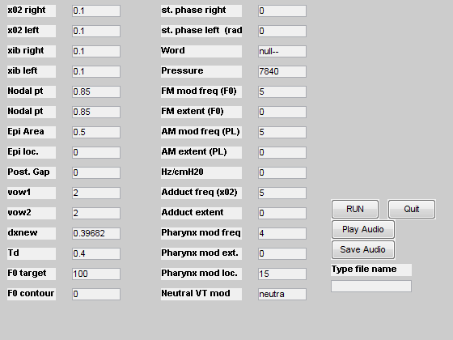

1. Listing of parameters in the window
   1. x02 right = right vocal fold adduction, if made larger voice will get breathier
   2. x02 left = left vocal fold adduction, if made larger voice will get breathier
   3. xib right = right vocal fold bulging, can vary from 0.01 to 0.2
   4. xib left = left vocal fold bulging, can vary from 0.01 to 0.2
   5. Nodal pt (right and left): point on the vocal folds around which vibration pivots
   6. Epi Area: x-sect area of the vocal tract near the glottis
   7. Epi loc.: location within the epi-laryngeal part of the vocal tract to impose the Epi Area. If set to be 0, this parameter (and Epi Area become irrelevant).
   8. Post. Gap.: Posterior glottal gap. Probably best to just leave at zero for now.
   9. vow1: first vowel in a vowel-vowel transition. Vowel code- 1=/i/, 2=/I/, 3=/E/, 4=/ae/, 5=/uh/, 6=/a/, 7=/aw/, 8=/o/, 9=/U/, and 10=/u/
   10. vow2: second vowel in a vowel-vowel transition. If vow1=vow2 then a static vowel is produced.
   11. dxnew: length of each section in a vocal tract area function. There are 44 sections in an area function so the default length of 0.396826 produces a total VT length of 17.46 cm. This can be made smaller or larger to shorten or lengthen the vocal tract.
   12. Td: duration of the simulated utterance in seconds. Can be set to any thing up to 9 seconds (however, this would require a lot of computation time).
   13. F0 target: The fundamental frequency of vocal fold vibration.
   14. F0 contour: can be set to 0, 1, or 2. 0 creates a monotone – F0 will be exactly constant over the duration of the simulation. 1 creates an F0 contour as a statement, 2 is a question (sort of).
   15. st. phase (L and R): leave at 0
   16. Word: this version can create three words: Iowa, Ohio, and Hawaii. To create these words you must type in six characters. I.e. – Iowa = iowa--, ohio = ohio--, Hawaii = hawaii
   17. Pressure: Tracheal pressure in dyn/cm2
   18. FM Mod Freq. (F0): Creates modulation of F0. Can be set to any number between 1-10 Hz
   19. FM Mod Ext.: Extent of the modulation. Enter as a number less than 1. 0.05 is a good place to start (i.e. 5% extent). If set to zero, no modulation will be imposed.
   20. AM Mod. Freq (PL): Amplitude modulation freq. This modulates the tracheal pressure. Can be set to a number between 1-10 Hz
   21. AM Mod. Ext.: Extent of AM. Enter the same way as FM ext.
   22. HzcmH20: This is the amount of increase in F0 per change in tracheal Pressure
   23. Adduct freq and extent: Modulates the vocal fold adduction
   24. Phar. Mod Freq and Extent: Allow for modulation of the area within the pharynx
   25. Phar. Mod Loc.: Location within the vocal tract to impose a modulation. Can be set to any number from 1 to 44.
   26. Neutra VT mod: leave as default
2. You can change any number of the parameters and hit the RUN button to generate a new simulation. You play it any number of times by hitting the “Play Audio” button. If you want to save a simulation as a wav file you can type a file name (without the *.wav extension) into the box below “Type file name” and then hit “Save Audio.” The file will be saved in the current folder.
3. To save relevant signals and parameters in matlab format: >>save filename.mat q r t . Each of “r” “q” and “t” are matlab structures. “r” contains signals, “q” contains parameters, and “t” contains some of each (“t” is less useful than the other two structures).

**ModerMouth Instructions without GUI 03.12.09**

1. At the matlab prompt type:

>>init_params

1. Then type this:

>>[audn,ugn,t,r,tv,areas,lgths,fo,p] = ModerMouthExecTremor(q);

1. The output signals are returned in structure “r”; the output sound to be played back at 44100 Hz is “audn” (i.e. type >>soundsc(audn,44100) )
2. As a demo for changing the area function and generating a non-montonous F0 contour:

>>load bs_origvowels.mat

>>q.areas = aa;

>>q.F0contour = 1;

>>[audn,ugn,t,r,tv,areas,lgths,fo,p] = ModerMouthExecTremor(q);

>>soundsc(audn,44100)

Now increase the duration to 1 second:

>>q.td = 1.0;

>>[audn,ugn,t,r,tv,areas,lgths,fo,p] = ModerMouthExecTremor(q);

>>soundsc(audn,44100)